The digestive System
How many parts can you label on here?
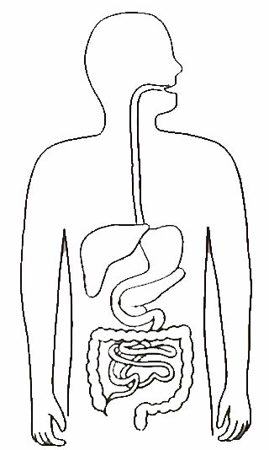
Connect the correct word to the correct sentence?
word |  | Meaning
Stomach |  | Where most chemical digestion and food absorption occurs.
Digestion |  | The crushing, churning and grinding of food.
Mechanical digestion |  | Special chemicals that speed up or bring about the digestion of food particle into tiny molecules.
Villi |  | The breakdown of food into particles small enough to be absorbed through the walls of the gut.
Small intestine |  | A muscular bag that churns food. It is where the digestion of proteins starts.
Enzymes |  | They are finger like projection on the lining of the small intestine and they increase the area available for the absorption of food.

